
<P_AP_ANZ_003_046_CustomerDocket_CityFM>
<Customer Portal - City FM Portal>
Process Technical Design Document (PTDD)

Process ID | P_AP_ANZ_003_046_CustomerDocket_CityFM
Business Unit | ANZ
Operation Unit | IT
Process Name | Customer Portal - City FM Portal

Document Version Control
Date Issued | Version | Description/Remark | Attachment | Author
2025-12-09 | 1.0 | Create the document:  - Introduce the background of the process  - Introduce the solution of the process  - Introduce specific functions of the process |  | DHC - Yang Jin-Yu

Contents
1 Background 3
2 Process Flowchart 4
3 Process Technical Design 5
3.1 Process Analysis 5
3.2 API Design 5
3.3 Specific Design 5
3.3.1 Business Impact Assessment 5
3.3.2 Process Structure 6
3.3.3 Process Workflows 7
3.3.4 Process Activity 7
3.3.5 Remind Mail 8
4 Assets and Constants 10
4.1 Assets 10
4.2 Constants 10
5 QA 11
6 Approvals 11

Background
The solution will automate the customer dockets maintenance for customer portals (City FM), Login to customer portal, get docket document and maintain dates in docket item and the complete them.
The robot will:
- Download Source Data Document
- Login to City FM Portal
- Retrieve Operation Data
- Get Docket Information
- Login to VIEW Platform
- Search Docket
- Download Docket Document
- Get Key Information from Docket Document
- Maintain and Complete the Work Order
- Work Order Maintenance (City FM)
- Execution Report & Remind Mails
- Generate Execution Report
- Success Remind Mail
- Business Exception Remind Mail (No Operation Data)
- Business Exception Remind Mail (Others)
- System Exception Remind Mail

Process Flowchart

Process Technical Design

Process Analysis

API Design

Libraries

Specific Design

Business Impact Assessment
- Confidentiality: The impact if the data is disclosed to an unauthorised person
  - What is the highest classification of the data processed? – <work order>
  - Does this process contain any personal data? – <N>
  - Does this process contain any sensitive data e.g., commercial, security? – <N>
- Integrity: The impact if the data/process is modified
  - Does this process affect any external / operational services? - <Y>
- Availability: The impact if the data/process is unavailable
  - Are there any SLAs in place (internally or externally)? – <Externally>
  - Does this process have a defined Recovery Time Objective? (The maximum time that this process can be down for)? - <2 times>
  - Does this process have a defined Recovery Point Objective? (The amount of tolerable data loss)? – <N>

Process Structure
The architecture of process is REF (Robotic Enterprise Framework)
- Set per work order as one transaction item
- If process occurred any business exceptions, robot will record exception information in execution summary report and log message. (The process should not be interrupted and proceed next transaction item)
- If process occurred any system exceptions, robot will record the execution information in execution summary report and log message (Retry 2 times/transaction item. The process should not be interrupted and proceed next transaction item)
Define a Datatable to storage the execution results of transaction items, the fields are:
Field Name | Storage Data | Comment
Customer Portal | The name of customer portal | Define a rule by RPA team to distinguish different customer portals  (Mandatory)
Type | Get from docket document  (Docket type) | Mandatory
Work Order No. | Get from source data document (Col-WO) | Optional
Docket No. | Get from source data document (Col-Docket) | Mandatory
Work Order URL | Get from source data document (Col-WO) | Mandatory
Docket URL | Get from source data document (Col-Docket) | Mandatory
Docket Document | Get from VIEW | Optional
Asset Tag | Get key information from header and mapping with corresponding asset tag | Mandatory
Root Cause | Wear and tear | Mandatory
Status | I’m complete – if any key words ‘Lift returned to service; No faults found; Running on arrival; RTS’ in Comments and Recommendations | Optional
Time In | Get from docket document | Optional
Time Out | Get from docket document | Optional
Action Details | Get from docket document/default value | Optional
Execution Result | Robot generated | Success, Warning, Failed (Mandatory)
Comment | Record execution details (exception messages) | Optional

Process Workflows
- Browser
  - CustomerDocket_CloseBrowser.xaml
  - CustomerDocket_KillBrowser.xaml
  - CustomerDocket_DownloadDocketDocument_City.xaml
  - CustomerDocket_UpdateDocket_City.xaml
  - CustomerDocket_LoginCustomerPortal.xaml
- Excel
  - CustomerDocket_CloseExcel.xaml
  - CustomerDocket_KillExcel.xaml
  - CustomerDocket_GenerateExecutionReport.xaml
- PDF
  - CustomerDocket_GetDatafromPDF.xaml
- Local Folder
  - CustomerDocket_InitLocalFolder.xaml
  - CustomerDocket_DownloadSourceDataList.xaml
- Email
  - CustomerDocket_SendMail.xaml

Process Activity
- Excel (UiPath.Excel.Activities)
- Folder (UiPath.System.Activities)
- Browser (UiPath.UIAutomation.Activities)
- Mail (UiPath.Mail.Activities)

Remind Mail
- Success Remind Mail
The robot will send success remind mail to end users when the process execute completed without any exceptions
  - Subject: [RPA-Success] Customer Docket (City FM) - Execute Success
  - To: Business user mail group
  - Cc: RPA support mail group
  - Attachment: Customer Dockets Execution Summary Report (yyyyMMdd).xlsx
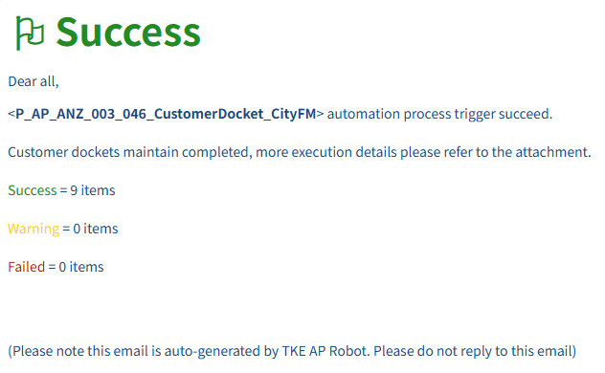
Attachment demo:
- Business Exception Remind Mail (No Operation Data)
The robot will send business exception remind mail to end users when the process execute with any business exceptions (no operated items)
  - Subject: [RPA- Business Exception] Customer Docket (City FM) - Execute With Business Exception
  - To: Business user mail group
Cc: RPA support mail group
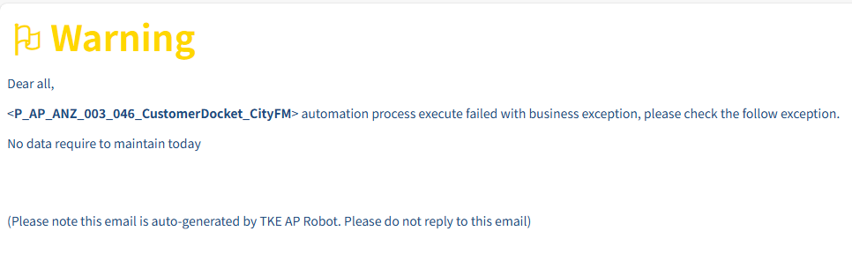
- Business Exception Remind Mail (Others)
The robot will send business exception remind mail to end users when the process execute with any business exceptions (Such as account expired)
  - Subject: [RPA- Business Exception] Customer Docket (City FM) - Execute With Business Exception
  - To: RPA support mail group
Cc: N/A
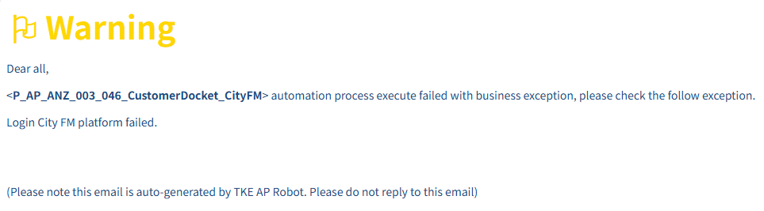
- System Exception Remind Mail
Robot will send system exception remind mail to RPA support team when the process execute with any system exceptions (Such as elements not found, operated failed, out of delay time)
  - Subject: [RPA- System Exception] Customer Docket (City FM) - Execute With System Exception
  - To: RPA support mail group
Cc: N/A
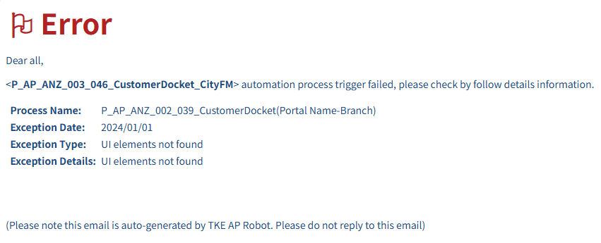

Assets and Constants

Assets
Asset | Type | Description
A_AP_ANZ_003_046_CITYFMURL | Text | City FM portal URL

Constants
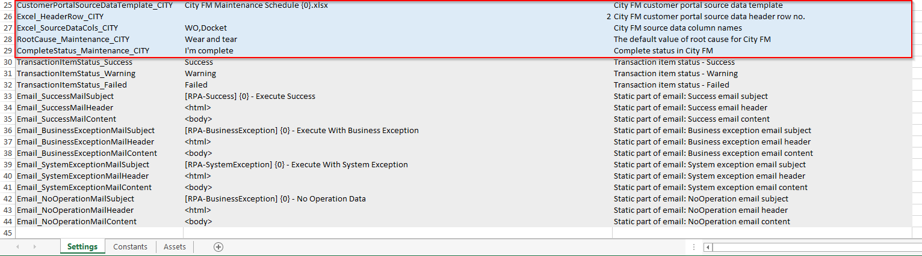
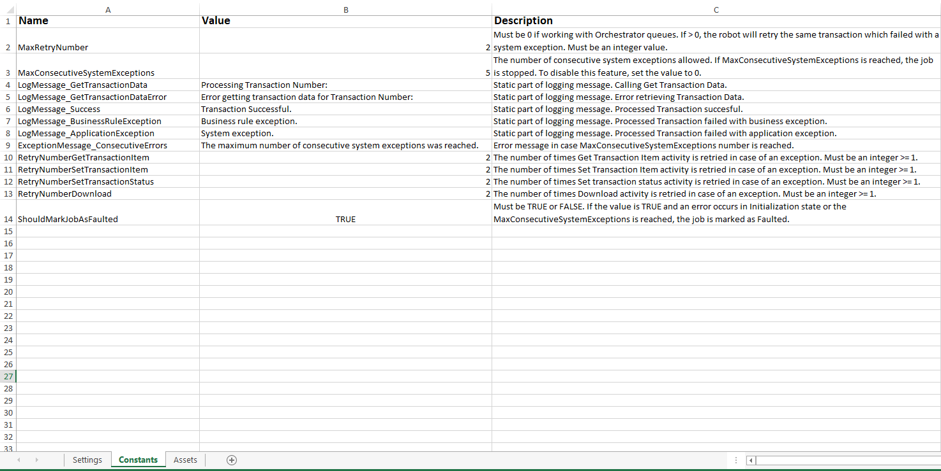
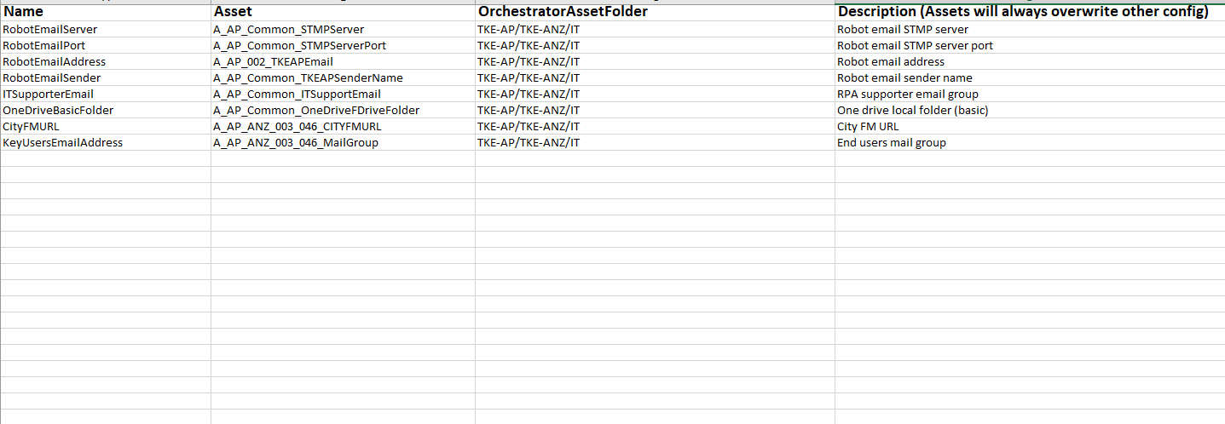

QA
No. | Question | Answer

Approvals

Support Team Date

RPA Service Owner Date

